# TECHNICAL SUPPORT DOCUMENTATION

***COMPANY NAME : EPHRAIM CONCEPTS***

***LOCATION: ADENIYI JONES, IKEJA, LAGOS STATE***

*By*

*Osoba Damilola*

# Contents

This Documentation is divided into these basic sections and sub divided as seen in the diagram below:

* Introduction
* General Infrastructure
* Network Infrastructure
* Storage Infrastructure
* Security and Verification System

*NOTE: Click to navigate*

# INTRODUCTION

Ephraim Concepts is a new private Information Technology Company based in Lagos, Nigeria with a work force of less than 10 staff. We render various IT services ranging from Networking to Storage : Storage Services because as businesses continue to experience exponential growth, there is a demand for storage- capacity as well as 24/7 availability. Research shows that companies are experiencing on an average greater than 50 percent annual information growth. Thus tradition storage devices become too complicated for businesses as the complexity of IT environments continue to increase.

Therefore the EMC VNX is the new Unified storage for enterprise organizations , designed for IT generalists with limited storage enterprise. This makes it a practical solution for us to offer as a service here in Nigeria. We currently work in Conjunction with Square One, a Home Care& Ambulance Service also in Lagos, Nigeria. Ephraim Concepts are Oracle Partners and are also part of the Powerlink/EMC Community.

# GENERAL INFRASTRUCTURE

Our Infrastructure at Ephraim Concepts basically consists Network and Storage devices.This infrastructure is simple which leaves room for improvements as the company expands. The general infrastructure is made up of Access controls for security, Access points for Connectivity and an EMC VNXe Unified Storage System, all connected to our central Network . Our Infrastructure is quite simple but yet complex within its layers. The major wiring was d Our Infrastructure is made up of the following equipment.

**NETWORK DEVICES**

* CISCO 1941 Router
* Hp Server
* Cisco SG100-24 Network Switch
* D-Link Access Points
* Spectranet (ISP)

**STORAGE DEVICE**

* EMC VNXe 3300 series(DPE and DAE) – 5TB

**COMMUNICATION**

* PABX(24 Extensions)

**SECURITY**

* Access Control
* CCTV Surveillance(15 cameras)
* DVR Monitor(8 channels)

The diagram below shows the interconnection between all our devices

# GENERAL INFRASTRUCTURE DIAGRAM

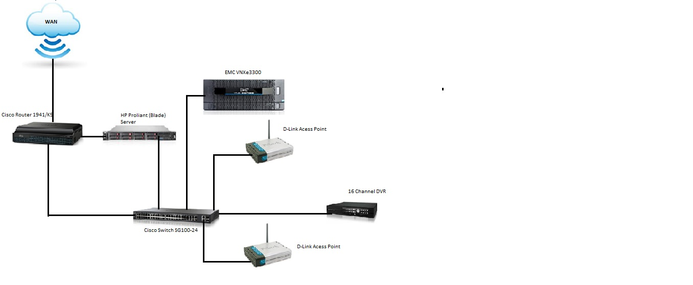

# OUR NETWORK INFRASTUCTURE DIAGRAM

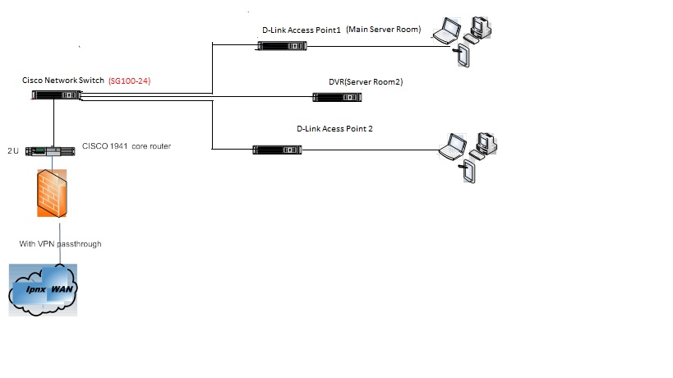

## CISCO ROUTER 1941/K9

Our **router** forwards data packets between computer networks, creating an overlay internetwork. The router is connected two data lines from our network. When a data packet comes in one of the lines, the router reads the address information in the packet to determine its ultimate destination. Then, using information in its routing table or routing policy, it directs the packet to the next network on its journey. Routers perform the "traffic directing" functions on the Internet. A data packet is typically forwarded from one router to another through the networks that constitute the internetwork until it gets to its destination node. Our router is also configured to perform its normal routing functions and simultaneously act as a DNS Server.

| **CISCO 1941 ROUTER DETAILS** | |
| --- | --- |
| **Manufacturer** | Cisco Systems, Inc |
| **Manufacturer Part Number** | CISCO1941/K9 |
| **Product Type** | Router |
| **Form Factor** | External - modular - 2U |
| **Dimensions (WxDxH)** | 34.3 cm x 29.2 cm x 8.9 cm |
| **Weight** | 5.8 kg |
| **DRAM Memory** | 512 MB (installed) / 2 GB (max) |
| **Flash Memory** | 256 MB (installed) / 8 GB (max) |
| **Routing Protocol** | OSPF, IS-IS, BGP, EIGRP, DVMRP, PIM-SM, IGMPv3, GRE, PIM-SSM, static IPv4 routing, static IPv6 routing |
|  |  |
| **Data Link Protocol** | Ethernet, Fast Ethernet, Gigabit Ethernet |
| **Network / Transport Protocol** | IPSec |
| **Remote Management Protocol** | SNMP, RMON |
| **Features** | Cisco IOS IP Base , firewall protection, VPN support, MPLS support, Syslog support, IPv6 support, Class-Based Weighted Fair Queuing (CBWFQ), Weighted Random Early Detection (WRED) |
| **Compliant Standards** | IEEE 802.3ah, IEEE 802.1ah, IEEE 802.1ag |
| **Power** | AC 120/230 V ( 50/60 Hz ) |

## HARDWARE INFORMATION SUMMARY

## WIRING

|  |  |
| --- | --- |
| **Item** | **Description** |
| Wired By | Neosoft technologies (08023130733) |
| Cable Type | Systimax Cat 5e |
| Central Wiring Location |  |
| Wiring Diagram Stored Where | Support documentation |

## SWITCH

|  |  |  |  |  |  |  |
| --- | --- | --- | --- | --- | --- | --- |
| **Make and Model** | **SSID** | **Protocol** | **IP Address** | **Encryption**  **Settings** | **Channel** | **Connected To** |
| Cisco SG100-24 | N/A | ethernet |  | N/A | N/A | access |

## ACCESS POINTS

|  |  |  |  |  |  |  |  |
| --- | --- | --- | --- | --- | --- | --- | --- |
| **Make and Model** | **Speed** | **Location** | **Ports** | | **IP Address** | **User/**  **Password** | **Passphrase** |
| **Total** | **Free** |
| D-Link(EphraimIT) | 54 | Hallway |  |  | 192.168.0.51 | admin(username only) | ephraimit |
| D-Link(SquareOne) | 54 | Hallway |  |  | 192.168.0.50 | admin(userna) | squareone |
| **INTERNET IP RANGE** | **172.16.0.50 to 172.16.0.200** |  |  |  |  |  |  |

# ROUTER

|  |  |  |  |  |  |  |
| --- | --- | --- | --- | --- | --- | --- |
| **Make and Model** | **Internal IP** | | **External IP** | | **User/Password** | **Purpose** |
|
| Cisco 1941  Integrated Services Router | IP | 172.16.0.1 | IP | 41.58.138.62 |  | Core router/DNS |
| SM | 255.255.255.0 | SM | 255.255.255.252 |
| GW | 172.16.0.1 | GW- | 41.58.138.61 |
|  |
| DNS Server | 41.222.70.179 |

## FIREWALL

|  |  |  |  |  |  |  |
| --- | --- | --- | --- | --- | --- | --- |
| **Make and Model** | **Internal IP** | | **External IP** | | **User/Password** | **Rules** |
|
| Cisco | IP | 172.16.0.1 | IP |  | n/a | Deny All, exceptions : session outbound from internal IP, content filter |

# SERVER

|  |  |
| --- | --- |
| **Hardware item** | **Description** |
| Computer model | HP ML Proliant |
| S/N |  |
| BackPlane |  |
| CPU | Intel Zeon |
| Hard disk(s) | N/A |
| Floppy disk | N/A |
| RAM | 12GB |
| NIC |  |
| Hard drive controller card |  |
| CD-ROM | N/A |
| Tape backup | N/A |

Licenses

|  |  |  |  |
| --- | --- | --- | --- |
| Components | Applications | Purpose | Remarks |
| Operating system | windows server 2012 | Windows Operating System | Unlicensed |
| Applications | Mfiles 10.0 | Electronic Document Management System | Trial Version expired |
| Virtualization | Vmware Vsphere client 6.0  VMware Exsi 6.6 | Virtualised Server Administration  Virtualisation Application | Trial Version expired  Trial Version expired |